Excel Report
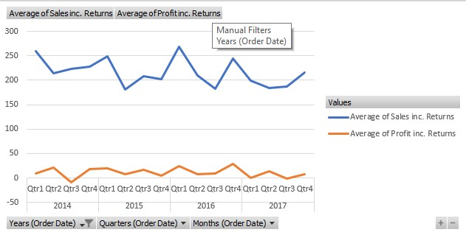
Firstly, let’s look at the general overview from the previous years. What we see is that quarters 2 and 3 seemingly are the worst sales quarters in each year. To increase sales across the board we would need to do a deep dive into what is causing this downturn in sales in these quarters and then put a plan in place to then generate more consistency in sales from quarter to quarter.
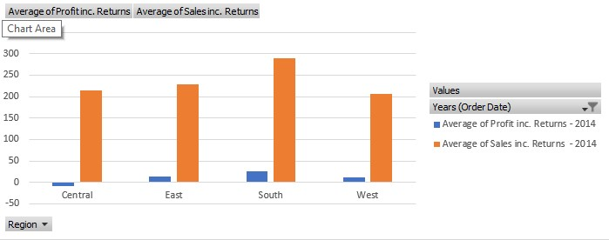
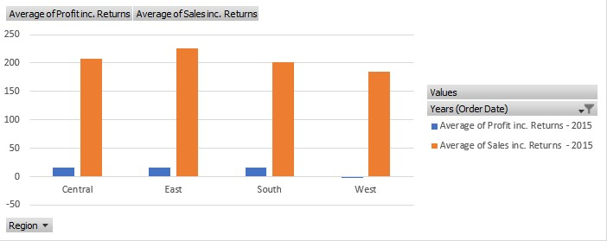
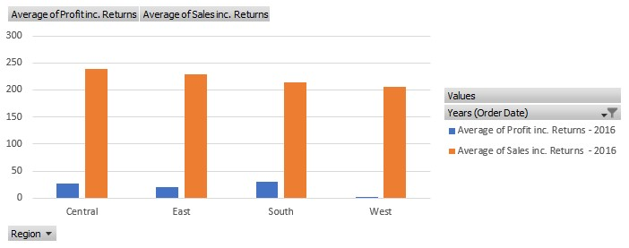
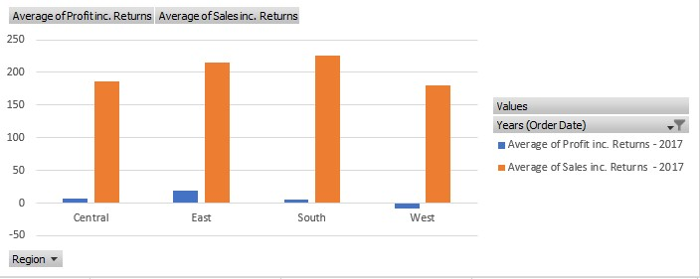
Now we move on to regional data, in these 4 graphics one notices that the poorest performing region in all 4 years is the West. One suggestion could be to shutdown sales to the West because when we look deeper, we can see that as well as sales being poor it is also costing us money to sell there rather than being profitable, which is concerning. Another possible suggestion would be to improve advertising in the West, so that we can generate more sales. On average we are doing well in the East and South regions, something we could look at is tapping into those markets more, building relationships with recurring customers and generating more sales that way.
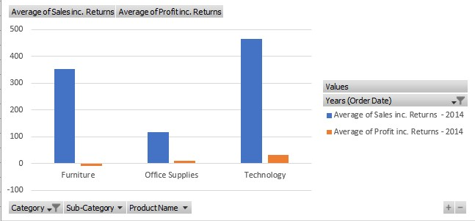
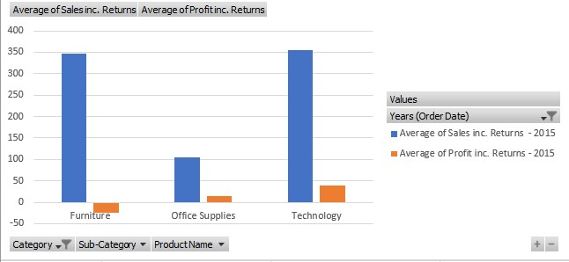
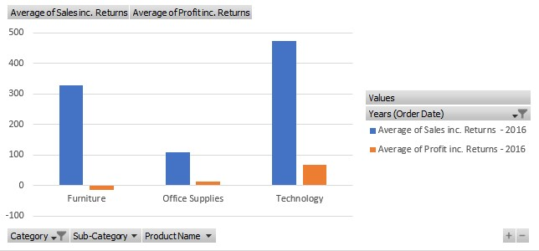
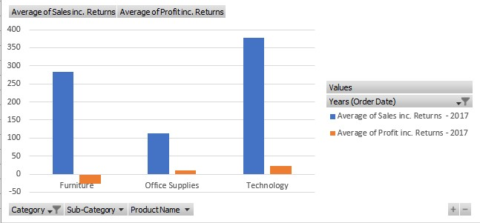
What we notice from the products data is that we are struggling for sale in the office supplies department. To improve these figures, we could create relationships where we sell office supplies to recurring customers on a standing order so that we have constant sales in this department. A suggestion would be to stop selling furniture, although sales are high there is not a single year in which this department makes profit, so what I would recommend is to shut down the furniture department and focus these resources on office supplies so we can boost sales in this area instead.

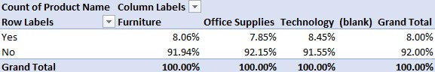
Proportionately, technology has the most returns, it’s possible this could lead to the company gaining a bad reputation in terms of the technology it provides. So, to increase sales we could investigate the reason behind these returns and rectify the problems. However, the number of returns is not particularly a cause for concern, so this does not need to be addressed in the short term.
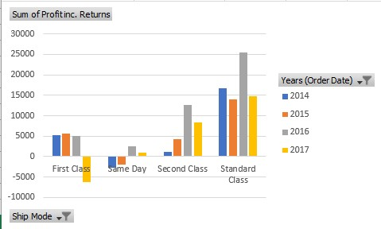
To increase profit, a suggestion I would make would be to remove the option for same day delivery, this option is running at a loss and is therefore bringing the profits down. Another cause for concern is the downturn in first class delivery for 2017, given how consistent the profits were while using it for the 3 years prior, I would watch this closely in the future but I wouldn’t remove it jus yet as it could just be an anomaly.
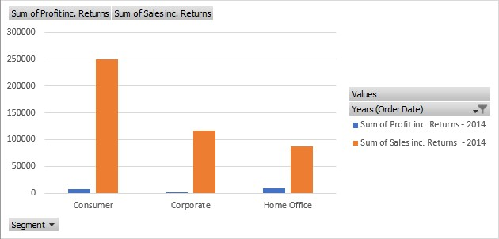
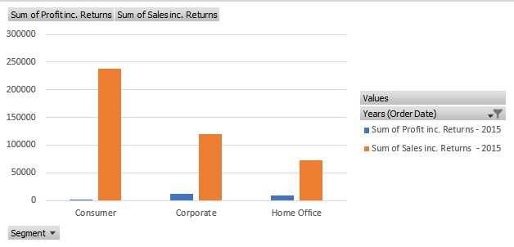

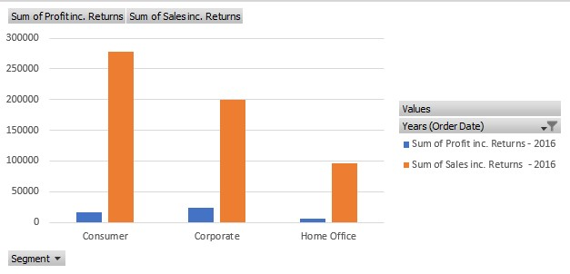
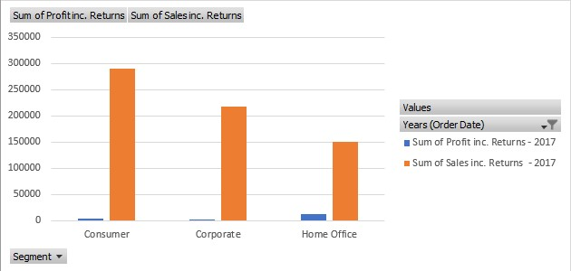
Now let’s focus our attention to the segments sales over the last 4 years. We notice that the lowest sales are coming from the home office segment, this could be due to most people having what they need provided for them by the company they work for. So, I would then turn my attention to the corporate segment, we should agree trade deals with companies to improve sales in the corporate segment, if they are providing people with what they need in order to work from home then we can create bundles which can provide these companies with the products they are handing out to their employees and in turn boosting sales in the corporate segment.

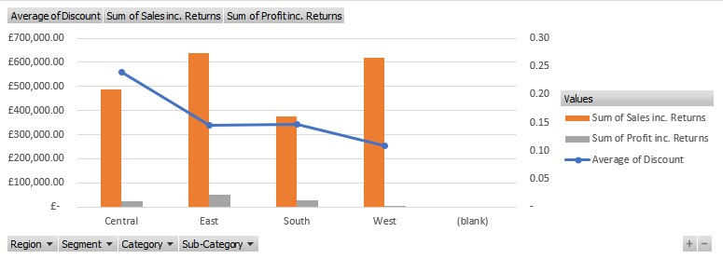
Here is a graph showing the discount per region that the company sells to. From this a suggestion would be to lower the discount to the central region and use this in the South, this is because the south is doing the worst in sales, if we improved the discount for companies in the south this could generate sales in the region.

